Hartford HealthCare– Israel Pilot Program Call for Proposals
May 19th – September 19th, 2022

The Israel Innovation Authority (the Authority) and Hartford HealthCare Corporation (HHC) invite interested Israeli companies to submit applications for research & development projects or pilot solutions in the healthcare-related technology field with HHC.
This call is open both to joint proposal for cooperation in R&D activities with HHC, and for pilot projects for companies that wish to pilot, scale-up and adapt their new innovative technologies and solutions.
HHC and the Authority are seeking to advance healthcare by helping Israeli companies get the evidence and assistance they need to fine-tune their development and to enter and be successful in the United States’ healthcare market.
HHC would serve as a real-world living laboratory for the Israeli companies to test and improve an existing process, service, or product; or to apply a new process to health care for the first time.
The goal of this collaboration is to accelerate the availability of medical innovations to the public, introduce Israeli healthcare technology to the U.S., and advance the development and deployment of discoveries for the benefit of patients everywhere.

The Authority provides resources to aid technology advancement for Israeli companies.
HHC is Connecticut’s (CT’s) only fully integrated health system that is leading the transformation of care in the 185 towns and cities we serve by providing high-quality, coordinated care that touches the lives of 17,000 people across CT and beyond. HHC has more than 360 access points (i.e., acute care hospitals, ambulatory care and surgical centers, and physician services). HHC has more than 30,000 colleagues and operating revenue of approximately $4.3 billion. HHC’s goal is to be number one for patient/customer experience in the Northeast of the United States by 2023 (#123).
By integrating multi-specialty providers into one system of healthcare delivery, HHC can offer coordinated care across the continuum, achieve economies of scale, make care more affordable, and focus on consistent, high-quality care.
HHC’s Innovation Ecosystem
The following HHC key strategic innovation assets and capabilities serve as a “sandbox” environment for emerging innovative digital health solutions and can serve as a resource for Israeli companies:

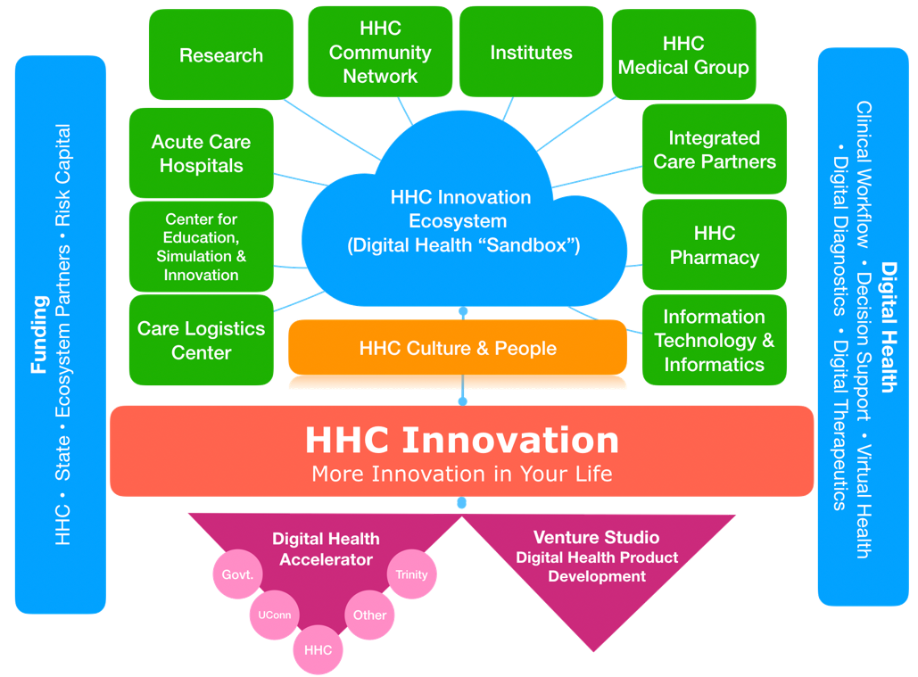

Focus Areas:
The digital health themes of interest to HHC include:
- Hospital/Care at home
- Health equity
- Population Health
- Clinical Decision Support
- Healthcare Access

Application Process

Deadline for submissions: 19/09/2022

What support do the Authority and HHC offer?
Successful Israeli applicant companies will receive funding from the Authority and in-kind (non-monetary) services from HHC.
The Authority can support R&D performing companies, registered and operating in Israel, with a grant of up to 50% of the approved Pilot or R&D Expenses Budget, according to its regulations and procedures.
- Research institutions as subcontractors to eligible companies.

When a project eventually results in sales of a product, service, or process, the financial support must be repaid in royalties to the Israel Innovation Authority according to its regulations. In general, royalties are paid at rates beginning at 3% of sales, depending on various criteria. Royalties are payable until 100% of the amount of the grant has been repaid with interest as provided in the applicable regulations. If the project does not result in sales, no repayment is required.

A collaboration agreement between successful applicant companies and HHC will need to be signed before project initiation.
Requirements
Cooperation proposals should be in line with the following requirements:
- The participation of at least one company from each country is mandatory. Research institutes and other companies may participate as partners or subcontractors in the cooperation project, respecting the financing rules of each country.
- The proposal should result in the development of an improved or new product or process with industrial application intended for commercialization in domestic and/or global markets, including proof of concept projects for technology-based solutions.
- The new product / process should be innovative, have relevant market potential, technological risk and add value to the economies of both countries.
- The project should demonstrate adequate balance and complementarity between the two partners in relation to the R&D phases.
- The project should present a clear competitive advantage and differentiated value proposition as a result of cooperation between the participants of the two countries (increase of knowledge base, access to R&D infrastructure, new fields of application, for example).
- Companies should present a strategy which, given their technological, commercial, and financial aspects, demonstrates their potential to introduce the new product / process into the markets of both countries and/or third countries.
- Partners in the project must agree in advance on the allocation of intellectual property rights (IP) between companies, as well as the marketing strategy. This agreement should reflect a proportional allocation and a fair return for both partners in relation to their respective investments.
- In a pilot project proposal, the IP rights will stay in the hands of the Israeli partner
- Partners in Israel and in Brazil should be able to implement the project and finance their respective shares.
- Any partnership whose cooperative R&D project is consistent with the above criteria may present it in this Call, in accordance with applicable national laws, rules, regulations and procedures.

Process and Timeline
Program launch | 19/05/2022
Agreement signing and submission to the Authority | 19/09/2022

Contacts

HHC  Candace Carlson  candace.carlson@hhchealth.org | Israel Innovation Authority  Alan Hofman  Business Development Manager  +972-3-715-7987  Alan.hofman@innovationisrael.org.il

