Israel - CABHI 3rd Call for Proposals

Canada-Israel Collaboration Program
The Centre for Aging + Brain Health Innovation (CABHI) and Israel Innovation Authority (IIA) are excited to launch their third round of the Canada-Israel Collaboration Program. This program is intended to accelerate the evaluation and adoption of innovative products and services that address the needs of aging adults and the challenges presented by an aging population.
CABHI and IIA invite Israeli companies to apply for the opportunity to trial their solutions with leading seniors care organizations from across Canada. Successful applicants will be partnered with one or more seniors care organizations and their pilot project will receive up-to CAD $250,000 in matching-fund support. Projects must last between 12-15 months and commence by September 2018.
It is expected that through this testing process, companies will be able to derive scientific evidence and user validation for their products or services, which is then intended to provide a stronger foundation for future uptake of their products or services by seniors’ care organizations. Applicants must have a matured product or service that they would like to test with older adults at a Canadian trial partner site.

As a first step, all interested companies must submit at https://baycrest.blitzen.com/form/CIC2018-EOI no later than 5 pm (EST) on February 23, 2018.

Innovation Themes

In 2018, the Centre’s focus will be on testing innovative solutions that are aimed at addressing the specific themes listed below:

- Aging in place: solutions that enable older adults with dementia to maximize their choice, independence and quality of life to enable aging in the most appropriate setting
- Caregiver support: solutions that support caregivers (formal and informal) in providing care to older adults with dementia

- Care coordination and navigation: solutions that help older adults, caregivers and healthcare providers coordinate care and transitions for older adults with dementia

- Cognitive health: solutions that focus on health promotion, prevention, early diagnostics, and slow progression of cognitive impairment for aging adults

All project applications must focus on one or more of the themes mentioned above. The product or service proposed must be sufficiently advanced in terms of technological development, and sufficiently supported by the applicant’s company in order to sustain a 12 to15 month trial (project time period includes writing of final project report). The product or service must have obtained all required regulatory approvals and be ready to be tested with human subjects. Selected projects will be expected to commence by September 2018.

The program proceeds in three phases:

- Vendor Expression of Interest: Israeli companies apply with solutions they wish to pilot with one or more seniors care organizations. Applications are reviewed and shortlisted by an external panel of industry and clinical experts at CABHI and IIA. If the solution is shortlisted, the company is eligible to participate in a trial-site brokering process facilitated by CABHI.

- Trial-Site Partnering: CABHI will match companies with to up-to two organizations interested in evaluating their solution. Trial sites are drawn from a database of leading healthcare organizations from across Canada, including long term care, community care, hospitals, and other healthcare service organizations. Companies and prospective trial partners meet to determine their mutual interest in partnering on a joint project proposal.

- Final Applications: Project proposals are reviewed and scored by an external panel of industry and clinical experts. Successful applicants are notified that their projects will receive funding support from CABHI and IIA.

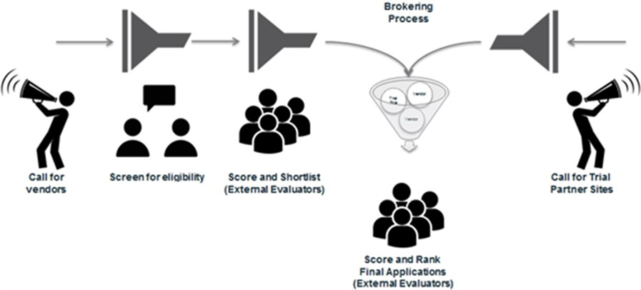

Program Eligibility

Applicant:

- Must be a for-profit company with head office registered and located in Israel.

- Must have good financial standing and have sufficient resources to complete an operational trial for 12 to15 months
Solution:
- Must clearly address at least one of the four innovation themes described above and demonstrate potential to significantly impact the health system

- Must have all licensing, certifications and regulatory approvals necessary for use during trial prior to project start (Company must provide evidence that all such certification have been acquired, or will be received prior to project start date.)

- Must be ready for use in an operational setting in its current form without major modifications or refinements to be undertaken during the project

- Must be commercially available for sale in Canada, or become available immediately available once the trial is complete

Project:
Initiative cannot involve basic research, primarily academic goals, capital investment in a portfolio of intellectual property, pharmaceutical clinical trials or incubators for startups.

Funding Available
This program will select 1 or 2 projects that will commence in September 2018. Eligible project costs will be shared between the successful Israeli company, the IIA and CABHI.

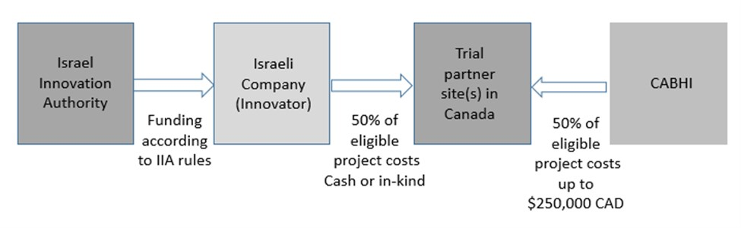
Project Budgets
The applicant shall submit two budgets as follows:
- Budget A to CABHI
- Budget B to IIA
Budget items in one budget cannot be included in the other budget.

Funding from CABHI:
Each selected applicant will be able to lever a maximum of $250,000 (CAD) from CABHI to support up to 50% of the eligible project costs specifically associated with validating their innovation. The project will be undertaken at the identified trial-partner site(s) located in Canada. Funds will flow directly to the trial.

Partner site(s), and be spent on costs directly relating to the pilot evaluation according to CABHI’s Eligible Expense Guidelines. Funds may not be used to directly compensate the company.

Funding from the IIA:

Selected applicants can receive additional funding from the IIA according to IIA’s funding rules. These funds will be provided by IIA directly to the selected Israeli company. The selected Israeli company must match funding provided by IIA.

Funding from the selected company (applicant):
In addition to matching funds provided by the Israeli company to match IIA funding, it must also match CABHI’s contribution through a blend of cash and/or in-kind project support.

Flow of Funds from CABHI

CABHI will release an initial payment of 30% of its portion of the funding at the start of the project to the seniors’ care organization(s) where the validation testing will be conducted. Subsequent interim payments (two installments each of 30%) will be released upon receipt and approval of interim progress and financial reports from the trial site(s). A holdback of 10% will be released upon project completion and receipt of final progress and financial reports, outcomes and attestation from the seniors’ care organization hosting the validation testing regarding the use of funds.

Additional obligations

The selected company and trial partner site(s) (seniors’ care organization) will each be accountable for the completion of project milestones and deliverables as well as performance reporting. The selected company must have the right to use the intellectual property related to the product or service being tested, and have the right to commercialize such product or service.

CABHI will not obtain any ownership rights to the intellectual property associated with the product or service, but will retain the right to disseminate the results of the testing. The trial partner site(s) will also have the right to disseminate the results of the testing. However, if the innovator and seniors’ care partner choose to

co-develop the product, and create joint intellectual property, and the product is commercialized, CABHI shall receive a royalty on the sales of the product from the selected company. These arrangements, including the amount of the royalty, would be negotiated and entered into by the parties during the term of the project.

If and when the product or service is commercialized, the selected company providing the product or service must agree to make it available to CABHI and participating trial partner site(s) seniors’ care organizations at the lower of reduced rate below fair market value and the most favored national pricing.

Program Benefits

The benefits of participating in the Canada - Israel Collaboration Program include:

- An opportunity to have the company’s products, services and processes tested in a “living lab” environment in one or more of Canada’s premiere seniors’ care organizations, via access to a large population of diverse end-users across a spectrum of settings (including inpatient, outpatient, independent, assisted living and long-term care and community).

- An opportunity to generate objective scientific evidence and user validation of the effectiveness of the company’s product or service, which will support the advancement of brain health and aging care as well as help differentiate the product or service in the marketplace.

- An opportunity to establish a working relationship with leading Canadian seniors’ care organizations, which will add credibility to the company’s product or service.

- An opportunity to promote adoption of the product or service through a North American network of leading seniors’ care organizations following a successful trial.

CABHI and / or the trial partners will:

- Share some project costs related specifically to the trial.

- Develop connections with brain health and aging experts who have an interest in the innovator’s product or service, with a view to supporting knowledge-sharing and facilitating further collaboration and advancements.

- Provide access to a large population of end-users for the purpose of testing product or service across North America.

- Support the development or refinement of the protocols and assessment methodologies necessary for conducting a scientifically valid trial.

- Support execution of the trial including trial ethics, participant recruitment, data collection and data management.

- Conduct quantitative and qualitative analyses, interpret results and generate a final report to disseminate the findings.

Selection Criteria

All eligible applications will be evaluated based on the following selection criteria:

- Strategic Alignment: How well does the project align with CABHI’s Call for Innovation themes for 2018? How clearly defined and significant is the problem being solved?

- Quality of Solution: How effectively does the solution address the identified problem? What is the quality of the existing evidence? How innovative, unique or ‘breakthrough’ is the solution proposed? What is the potential for broad positive impact and advancement in the aging and brain health sector?

- Market opportunity/commercial merit: What is the demonstrated size and value of the potential market for the solution? What is the quality of the company’s business and service model? How ready is the solution to be scaled across Canada and beyond?

- Project goals: How will this project directly contribute to the company’s strategic approach and commercialization plan? What outcomes and metrics is the project seeking to produce?

- Company and team experience: Demonstrated track record of relevant successes and qualifications of key members of the project team

Applications will be reviewed and scored by a project evaluation panel that is comprised of an independent group of external reviewers having expertise in the clinical, applied research, business and technical fields. Recommendations from the project evaluation team will be considered by CABHI leadership for project selection to ensure balance and strategic alignment. CABHI reserves the right to select proposals that represent distribution of projects across the 2018 innovation themes and geographic spread across trial partners’ sites located across Canada.

NOTE: CABHI will not fund initiatives that involve basic fundamental research, academic-oriented goals, capital investment in a portfolio of intellectual property, pharmaceutical clinical trials or incubators for startups. CABHI reserves the right to decline any application and to modify or annul this Call for Innovations at any time, without incurring any liability.

Process and Timeline

Program announcement | January 8, 2018
Applicants submit online Expression of Interest | February 23, 2018 by 5 pm EST
CABHI and IIA invite shortlisted applicants to submit application | March 20, 2018
Shortlisted applicants jointly submit full online application along with identified trial partner site including letter of support | May 7, 2018 by 5 pm EST
CABHI and IIA notifies selected applicants | August 3, 2018
Sign agreements | August 31, 2018
Project start | September 2018
Project end | November 2019

Step 1:
Submit an expression of interest at https://baycrest.blitzen.com/form/CIC2018-EOI by completing the online form by 5:00 PM on February 23, 2018. All applications must be in English, and nothing confidential or proprietary should be included. You are granting no rights to any intellectual property by submitting an EOI.

Step 2:
The IIA and CABHI will review and shortlist eligible applicants based on selection criteria. Shortlisted applicants will be notified by March 20, 2018.

Step 3:
Shortlisted applicants will be introduced to prospective CABHI seniors’ care organization(s) best-suited to be a trial partner site. The shortlisted applicant together with the identified seniors’ care organization (trial partner site) will jointly complete an online application form by 5:00 pm (EST) on May 7, 2018. All applications must be in English, and contain no material that is confidential or proprietary. You are granting no rights to any intellectual property by submitting an application.

Step 4:
In addition, the Israeli company will also be required to apply for support from the IIA by May 7, 2018 at
https://innovationisrael.org.il/ and https://bakasha.innovationisrael.org.il/

Step 5:
The IIA and CABHI will review the submitted applications, including project scope, timeline, deliverables and expected outcomes, against the selection criteria. Applicants may be contacted for additional information during the review phase, and must be willing to make revisions to the project plan, if requested. CABHI will perform a final-stage evaluation and select successful applicants.

Step 6:
Successful applicants will be notified by August 3, 2018.

Step 7:
Contract negotiations will set out financial and in-kind contributions of the selected company and the trial partner and any other rights of CABHI including rights to disseminate the findings, with the signing of the final agreement targeted to be completed by August 31, 2018.

If contract negotiations do not result in an agreement in a reasonable amount of time (determined exclusively by CABHI), CABHI may terminate negotiations, terminate the program or invite an alternate applicant to engage in negotiations.

About the Centre for Aging + Brain Health Innovation (CABHI)
The Centre for Aging + Brain Health Innovation (CABHI), located at Baycrest Health Sciences (Baycrest) in Toronto, Canada, is a solution accelerator focused on driving innovation in the aging and brain health sector. Established in 2015, it is the result of the largest investment in brain health and aging in Canadian history.

CABHI is a first-of-its-kind partnership, bringing together players in healthcare, sciences, industry, and the government. Its mandate is to be a solution accelerator for the design, development, testing, and validation of technology and/or practice-related innovations that will allow older adults to age safely in the setting of their choice while maintaining their cognitive, emotional, and physical well-being.

Innovation in this sector is vital so as to address the brain health and care needs of an ever-increasing number of older adults. Accordingly, CABHI will facilitate collaborations between leading seniors’ care organizations in Canada and those innovators from around the globe having promising solutions in the following areas: non-invasive medical devices, emerging technologies, wellness and digital health solutions, healthcare delivery practices, therapeutic approaches, and practitioner/caregiver training and support.

About the Israel Innovation Authority
The Israel Innovation Authority (IIA),formerly known as the Office of the Chief Scientist of the Ministry of Economy (& MATIMOP),which is responsible for the country’s innovation policy, is an independent and impartial public entity that operates for the benefit of the Israeli innovation ecosystem and Israeli economy as a whole.

Its role is to nurture and develop Israeli innovation resources, while creating and strengthening the infrastructure and framework needed to support the entire knowledge industry.

As such, the IIA advises the government and Parliament (“Knesset”) committees regarding innovation policy in Israel and furthermore monitors and analyzes the dynamic changes taking place throughout the innovation environments in Israel and abroad. The Authority creates cooperation with counterpart agencies to promote technological innovation in the Israeli industry and economy. Learn more at http://www.matimop.org.il/about_authority.html

For further details, please contact Jonathan Cohen, the North America Desk Manager at Jonathan.Cohen@innovationisrael.org.il

